Web Application of caBench-to Bedside v3.1
End User Manual

Document Change History
Version Number | Date | Contributor | Description
V3.0 | May 10, 2009 | Washington University/Persistent Systems Ltd/National cancer Institute | Reviewed
V3.0 | July31,2009 | Washington University/Persistent Systems Ltd/National cancer Institute | Addressed comments by Documentation and Training Workspace
V3.1 | September 1, 2009 | Washington University/Persistent Systems Ltd/National cancer Institute | Initial Draft
V3.1 | September 18, 2009 | Washington University/Persistent Systems Ltd/National cancer Institute | Reviewed



This is a U.S. Government work. September 21, 2009

Development Teams
Development | End User Manual | Program Management
Chandrakant Talele¹ | Chandrakant Talele¹ | Dr. Rakesh Nagarajan²
Chetan Patil¹ | Madhumita Shrikhande¹ | Srikanth Adiga^{1, 2}
Chetan Pundhir¹ | Pooja Arora¹ | Chandrakant Talele¹
Deepak Shingan¹ | Mukesh Sharma² | Mukesh Sharma²
Gaurav Mehta¹ | Chris Piepenbring ⁴ | Stephen A. Goldstein³
Pallavi Mistry¹ | Stephen A. Goldstein³
Rajesh Vyas¹
¹Persistent Systems Limited | ²Washington University
³Sapient Corporation | ⁴Capability Plus Solutions

Contacts and Support
Training contact | cab2bsupport@bmi.wustl.edu
Customer support contact | cab2bsupport@bmi.wustl.edu

Copyright and License Information
Copyright Notice. Copyright 2005 “School of Medicine, Washington University in St. Louis” (“caBIG® Participant”). cancer Bench-to-Bedside was created with NCI funding and is part of the caBIG® initiative. The software subject to this notice and license includes both human readable source code form and machine readable, binary, object code form (the “caBIG® Software”).
This caBIG® Software License (the “License”) is between caBIG® Participant and You. “You (or “Your”) shall mean a person or an entity, and all other entities that control, are controlled by, or are under common control with the entity. “Control” for purposes of this definition means (i) the direct or indirect power to cause the direction or management of such entity, whether by contract or otherwise, or (ii) ownership of fifty percent (50%) or more of the outstanding shares, or (iii) beneficial ownership of such entity.
License. Provided that You agree to the conditions described below, caBIG® Participant grants You a non-exclusive, worldwide, perpetual, fully-paid-up, no-charge, irrevocable, transferable and royalty-free right and license in its rights in the caBIG® Software, including any copyright or patent rights therein that may be infringed by the making, using, selling, offering for sale, or importing of caBIG® Software, to (i) use, install, access, operate, execute, reproduce, copy, modify, translate, market, publicly display, publicly perform, and prepare derivative works of the caBIG® Software; (ii) make, have made, use, practice, sell, and offer for sale, and/or otherwise dispose of caBIG® Software (or portions thereof); (iii) distribute and have distributed to and by third parties the caBIG® Software and any modifications and derivative works thereof; and (iv) sublicense the foregoing rights set out in (i), (ii) and (iii) to third parties, including the right to license such rights to further third parties. For sake of clarity, and not by way of limitation, caBIG® Participant shall have no right of accounting or right of payment from You or Your sublicensees for the rights granted under this License. This License is granted at no charge to You. Your downloading, copying, modifying, displaying, distributing or use of caBIG® Software constitutes acceptance of all of the terms and conditions of this Agreement. If you do not agree to such terms and conditions, you have no right to download, copy, modify, display, distribute or use the caBIG® Software.
- Your redistributions of the source code for the caBIG® Software must retain the above copyright notice, this list of conditions and the disclaimer and limitation of liability of Article 6 below. Your redistributions in object code form must reproduce the above copyright notice, this list of conditions and the disclaimer of Article 6 in the documentation and/or other materials provided with the distribution, if any.
- Your end-user documentation included with the redistribution, if any, must include the following acknowledgment: “This product includes software developed by School of Medicine, Washington University in St. Louis.” If You do not include such end-user documentation, You shall include this acknowledgment in the caBIG® Software itself, wherever such third-party acknowledgments normally appear.
- You may not use the names “School of Medicine, Washington University in St. Louis”, “The National Cancer Institute”, “NCI”, “Cancer Bioinformatics Grid” or “caBIG®” to endorse or promote products derived from this caBIG® Software. This License does not authorize You to use any trademarks, service marks, trade names, logos or product names of either caBIG® Participant, NCI or caBIG®, except as required to comply with the terms of this License.
- For sake of clarity, and not by way of limitation, You may incorporate this caBIG® Software into Your proprietary programs and into any third party proprietary programs. However, if You incorporate the caBIG® Software into third party proprietary programs, You agree that You are solely responsible for obtaining any permission from such third parties required to incorporate the caBIG® Software into such third party proprietary programs and for informing Your sublicensees, including without limitation Your end-users, of their obligation to secure any required permissions from such third parties before incorporating the caBIG® Software into such third party proprietary software programs. In the event that You fail to obtain such permissions, You agree to indemnify caBIG® Participant for any claims against caBIG® Participant by such third parties, except to the extent prohibited by law, resulting from Your failure to obtain such permissions.
- For sake of clarity, and not by way of limitation, You may add Your own copyright statement to Your modifications and to the derivative works, and You may provide additional or different license terms and conditions in Your sublicenses of modifications of the caBIG® Software, or any derivative works of the caBIG® Software as a whole, provided Your use, reproduction, and distribution of the Work otherwise complies with the conditions stated in this License.
- THIS caBIG® SOFTWARE IS PROVIDED "AS IS" AND ANY EXPRESSED OR IMPLIED WARRANTIES (INCLUDING, BUT NOT LIMITED TO, THE IMPLIED WARRANTIES OF MERCHANTABILITY, NON-INFRINGEMENT AND FITNESS FOR A PARTICULAR PURPOSE) ARE DISCLAIMED. IN NO EVENT SHALL THE SCHOOL OF MEDICINE, WASHINGTON UNIVERSITY IN ST. LOUIS OR ITS AFFILIATES BE LIABLE FOR ANY DIRECT, INDIRECT, INCIDENTAL, SPECIAL, EXEMPLARY, OR CONSEQUENTIAL DAMAGES (INCLUDING, BUT NOT LIMITED TO, PROCUREMENT OF SUBSTITUTE GOODS OR SERVICES; LOSS OF USE, DATA, OR PROFITS; OR BUSINESS INTERRUPTION) HOWEVER CAUSED AND ON ANY THEORY OF LIABILITY, WHETHER IN CONTRACT, STRICT LIABILITY, OR TORT (INCLUDING NEGLIGENCE OR OTHERWISE) ARISING IN ANY WAY OUT OF THE USE OF THIS caBIG® SOFTWARE, EVEN IF ADVISED OF THE POSSIBILITY OF SUCH DAMAGE.

.

Contents

About This Guide 1
Purpose 1
Typical User 1
Topics Covered 1
Text Conventions Used 2
Chapter 1 Introduction 3
Conducting Research using caB2B Web Application 3
Getting started with caB2B 4
Starting caB2B Web Application 4
Home Page 4
Types of User 7
Understanding Queries and Limits 7
What is a Category? 7
What is a Limit? 8
What is a Query? 8
Application Workflow 9
How Web Application differs from the Client Application? 9
Chapter 2 Databases to Search 10
Introduction to Databases to Search 10
Steps to Configure Hosting Institutions 10
Chapter 3 Keyword Search 12
Introduction to Keyword Search 12
Steps to Perform Keyword Search 12
View Results 13
Multiple Queries 13
Result Table 13
Options on Result Page 15
Export Results 15
Chapter 4 Saved Searches 17
Introduction to Saved Search 17
Steps to Define Limits 17
View search Results 19
Result Table 19
Options on Result Page 21
Export Results 21
Chapter 5 Offline Query Execution 22
Introduction to Offline Query Execution 22
Steps to Execute Offline Queries 22
Query Dashboard 23
Chapter 6 Error Messages/Indicators and Problem Resolutions 26
Accessing secure data 26
Invalid login credentials 26
Failed Hosting Institutions 27
Appendix A Example for searching data 28
Keyword Search 28
Saved Searches 30
Appendix B Define Limit: Operators and Values 32
Index 34

About This Guide
This section introduces you to the caBench-To-Bedside Web Application V 3.1 manual. It contains the following topics:
- Purpose
- Typical User
- Topics Covered
- Text Conventions Used

Purpose
This manual provides the details of how to use cancer Bench-to-Bedside (caB2B) Web Application to search data (for example, Biospecimen data, Microarray data, etc.) available on the cancer Biomedical Informatics Grid (caBIG®). The user can search data using keyword searches or detailed saved searches. The user can export and save the retrieved data for further experimentation work or analysis. The user can also submit queries for offline execution and view the results later when the query is complete.

Typical User
This guide is designed for clinical and translational research scientist. The term translational research means transforming scientific discoveries arising from laboratory, clinical, or population studies into clinical applications to reduce cancer incidence, morbidity, and mortality (definition from National Cancer Institute’s Translational Research Working Group http://www.cancer.gov/trwg/TRWG-definition-and-TR-continuum). It begins at “the laboratory bench” with basic research. Scientists study a disease at a molecular or cellular level to come up with discoveries. These discoveries then progresses to the clinical level, or the patient's “bedside”
No special knowledge or skill is required to use the caB2B web application.

Topics Covered
If you are new to caB2B Web Application, read this brief overview. It explains what you will find in each chapter and appendix.
- “Chapter 1: Introduction” describes the scope and function of the Web Application.
- “Chapter 2Chapter 1: Databases to Search” describes the process of configuring service instances for a query
- “Chapter 3: Keyword Search” describes the process of searching data based on a keyword.
- “Chapter 4: Saved Searches” describes the process of searching data based on detailed saved searches.
- “Chapter 5: Offline Query Execution” describes the process of submitting query to run in background and viewing results sometime later.
- “Chapter 6: Error Messages/Indicators and Problem Resolutions” describes various error messages and troubleshooting options.
- “Appendix A: Example for searching data” describes an example query that can be executed using the caB2B Web Application.
- “Appendix B: Define Limit: Operators and Values” describes the various operators and their values that are available for defining limits.

Text Conventions Used
This section explains the conventions used in this guide. The various typefaces listed below represent interface components, keyboard shortcuts, toolbar buttons, dialog box options, and text that you type.
Convention | Description | Example
Bold | Highlights names of option buttons, check boxes, drop-down menus, menu commands, command buttons, or icons | Click Search.
URL | Indicates a Web address | http://domain.com
text in Small Caps | Indicates a keyboard shortcut | Press Enter.
text in Small Caps + text in Small Caps | Indicates keys that are pressed simultaneously | Press Shift + Ctrl
Italics | Highlights references to other documents, sections, figures, and tables | See Figure 4.5.
Italic boldface monospace type | Represents text that you type | In the New Subset text box, enter Proprietary Proteins.
Note: | Highlights information of particular importance | Note: This concept is used throughout this document.
{ } | Surrounds replaceable items | Replace {last name, first name} with the Principal Investigator’s name.
 | Indicates information of particular interest
  To select all the institutes check Select All.
WARNING! | Indicates that you should be particularly aware of the information provided
  WARNING! | You cannot abort a query.

Introduction
This chapter explains the scope and function of the cancer Bench-to-Bedside (caB2B) Web Application. It helps you understand how to use caB2B Web Application to fetch data for research work. It contains the following topics:
- Conducting Research using caB2B Web Application
- Getting started with caB2B
- Starting caB2B Web Application
- Home Page
- Types of User
- Understanding Queries and Limits
- Application Workflow
- How Web Application differs from the Client Application?

Conducting Research using caB2B Web Application
The National Cancer Institute cancer Biomedical Informatics Grid® (NCI caBIG®) project creates a common, extensible informatics platform that integrates diverse data types and supports interoperable analytic tools. caBIG® is developing separate applications that will facilitate individual steps involved in various biological experiments and analysis.
caGrid is the infrastructure for caBIG® that helps integrate these applications. It is used to perform investigations involving data integration and analytical services from diverse research communities.
caB2B Web Application (henceforth called as Web Application) leverages these tools in a user-friendly graphical user interface (GUI). It provides query templates that allow easy search and retrieval of data across the grid. Searches can be performed on selected locations using either form-based or keyword searches and data can be exported in CSV format. These data sources can be different applications storing similar kind of data. Web Application provides you following high-level functionalities:
- Query caGrid data service to obtain data
You can easily search for microarray data (from caArray), imaging data (from NBIA-National Biomedical Imaging Archive), biospecimen data (from caTissue) and nanoparticle data (from caNanoLab) across the grid without having to understand how the data is stored, retrieved and transmitted over caGrid. You can use keyword-based search or a more specific saved search to retrieve the data.
- Export data for further research use
You can export the results obtained from keyword or saved searches and use it whenever required. Application supports exporting results in comma-separated file (CSV) format.

- Query data from multiple institutions
You can execute your query to get data from multiple institutions at a time.

Getting started with caB2B
caB2B provides a platform to bridge the gap between the laboratory research and the clinical level. It enables information to be shared along the continuum from the scientific bench to the clinical bedside and back. The tool helps in querying the data available on caGrid. For example, it is possible to get information about tissue samples collected from patients suffering from Glioblastoma multiforme at any cancer center available on caGrid.
The caB2B suite is composed of three components:
- Web Application
- Administrative Module
- Client Application
The technical staff will install the entire caB2B suite. After installation, the administrator uses the Administrative Module to configure Client Application and Web Application. Only after initial setup and the configurations, you can use the Web Application to query the data sources of your interest.
.
- To install caB2B refer to caB2B Installation Manual.
- To configure Web Application, refer to caB2B Administration Manual and the caB2B Client Application End User Manual.
- To know more about the Client Application refer to the caB2B Client Application End User Manual.

Starting caB2B Web Application
To start the Web Application, open your web browser (Internet Explorer or Firefox) and enter the link of Web Application. If you want to use caB2B installed at your center, get the web address from the caB2B administrator at your center. Alternatively, to access the publically available application at the Washington University or National Cancer Institute, you can use get the web address from https://cabig.nci.nih.gov/tools/caB2B/.
The web browser will navigate to the home page of application, as shown below in Figure 1.1. Home Page.

Home Page
The home page shows the queries for one of the non-secure data source by default. Data available on caGrid can be categorized into two types:
- Non-secure data: Publicly available data (for example, microarray data available in caArray)
- Secure data: Data that is accessible to authenticated users (for example, Biospecimen data available in caTissue).
Following image shows the home page of Web Application.
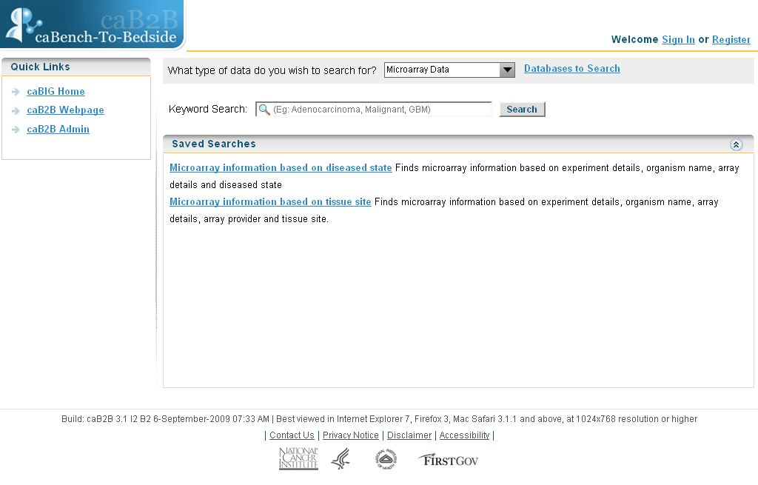
Figure 1.1. Home Page
Home page displays following information:
- Sign In or Register
To access secure data you need to login to the Web Application with your production caGrid credentials. To login to the application, click Sign In link at the top of the page (refer to Error: Reference source not found). If you do not have caGrid credentials then you can create one by clicking Register link.
- Quick links
Quick links refer to the caBIG® Home Page, caB2B Web Page and caB2B Administrative Module. You can navigate to these applications from the Web Application.
- What type of data do you wish to search for?
It displays all types of data that you can query using the Web Application. The queries in the saved searches panel are updated depending on the type of data. The administrator will define the types of data you can search for using the Administrative Module.

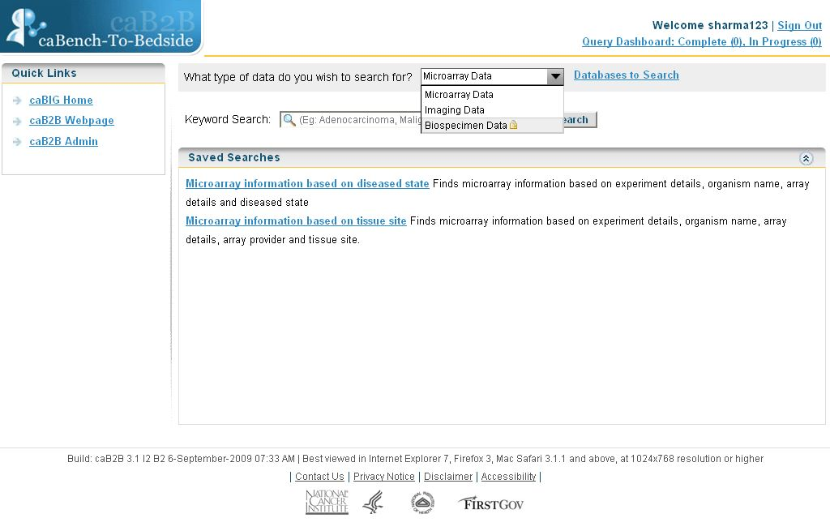
Select type of data
Figure 1.2. Home page showing types of data
- Databases to Search
For databases to search, refer to
- Keyword Search
You need to provide a word/s to get the results from a keyword search. The application would search selected databases for the given word. For more details of executing a keyword search, refer to Keyword Search. For example, you can search for a keyword Melanoma, for more details refer to Example for searching data.
- Saved Search
A saved search is a systematic way to find data where you will provide specific search criteria. It allows you to set conditions on available limits. For more details of executing a saved search, refer to Saved Searches. For example, you can search for Tissue specimen details with Clinical Diagnosis as Melanoma, for more details refer to Example for searching data.
- Query Dashboard
Signed in user can submit queries for offline execution. All such queries are executes in the background. You need not wait for the query execution to complete. You can submit queries for offline execution and later return to query dashboard to view results and query details. To know more about offline query execution, refer to Offline Query Execution.

Types of User
The application supports two user roles – Anonymous User and Grid User. You can search for data without actually signing in, although only non-secure data is searchable. All such users who are querying for data without signing in are Anonymous Users.
You can sign into the application using their production caGrid credentials to search secure data. All such users who sign in are Grid User. To sign into the application, follow the steps given below:
- Click on the Sign In link, at the top right hand corner on the Home Page.
- Enter User Name and Password (refer to Login page).
- Click Login.
- If you make an error while entering data, click Reset, to clear the fields.
- To return to the home page click Home link at the top right corner
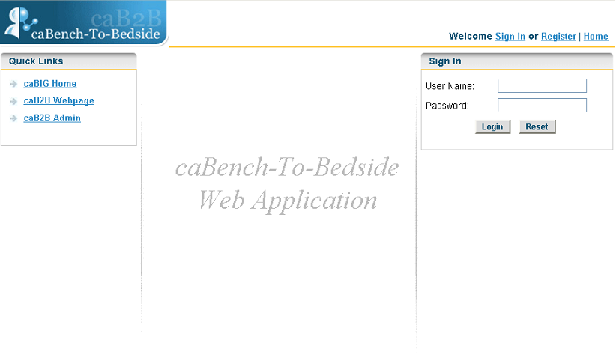
Figure 1.3. Login page
If you do not have a production caGrid account, then click on the Register link on either the home page or the login page. This will navigate you to the caGrid registration page. You can create a user account from there.

Understanding Queries and Limits
Queries and limits form the basis of the web application. Queries help you to fetch data from various applications. The limits set on the queries decide what result would be fetched from the application. To understand the queries you need to understand a category.

What is a Category?
A category is a collection of searchable attributes of an application/model. A user can use a category to search data. Every domain object in an application/model is, trivially, a category. For example, Participant is a domain object from caTissue Core application.
Examples:
The Participant class consists of the following attributes:
- Identifier
- First Name
- Last Name
- Gender
- Race
The Gene Annotation class consists of the following attributes:
- Entrez Gene ID
- Gene Symbol
- Gene Name
- GenBank Accession Number
- Taxonomy ID
- Chromosome

What is a Limit?
A limit is a condition (or criterion or predicate) on a category. It is the smallest unit of a query. Data is fetched depending on what limit is set on a category.
For example, for the Participant category above you can set a limit to fetch all female participants. Thus, we are defining a limit on Participant category’s Gender attribute. Each such individual condition is called Limit.

What is a Query?
A collection of limits is a query. Example of a query is find all female participants who have DNA specimens collected from their breast. This query has multiple limits:
Participants with Gender as Female
Specimens with Type as DNA
Tissue with Site as Breast
A combination of all these limits forms a query. In the Web Application, you would be executing queries that will have a single or multiple limits.

caB2B administrator creates the saved-searches and the keyword queries using Client Application.

Application Workflow
The general workflow within the application follows the steps outlined below:
- Access the caB2B web application home page.
- Login if you want to query a secured data service.
- Select type of data from What type of data do you wish to search for?
- Select the institutions to be queried
- Execute a keyword search or saved search
  - Refer to Chapter 3: Keyword Search for details of keyword query
  - Refer to Chapter 4: Saved Searches for details of saved searches
- Navigate to the results page.
- Wait for the query to complete to download the results or submit it for offline execution.
- Navigate to the Query Dashboard to view the status of the queries submitted for offline execution.
- Export the results for the queries.

How Web Application differs from the Client Application?
Web Application is an easy to use tool that is accessible to users over the web and does not require any download and installation. caB2B Web Application allows users to perform predefined queries to retrieve microarray data (caArray), image data (NBIA), biospecimen data (caTissue Core) and nanoparticle data (caNanoLab) across caGrid without having to understand how the data is structured and stored, how it is retrieved and transmitted over grid. Users do not need to rely on the understanding of domain models for the caBIG® applications. Administrator defines queries based on common use cases and those are available for users to execute. A user can perform either a keyword search or a saved search (like canned query). Users can export the results retrieved for future reference and analysis

Client Application, on the other hand, is a java-based desktop application that needs to be downloaded. Advanced users with knowledge of caBIG® applications and their domain models can create and save custom queries. These queries can be accessed through either the Client or the Web application. User can create the queries and execute them for any caGrid data services. You can also save the results returned in the form of a 'virtual experiment'. Various graphical components like scatter plots, bar charts etc are available to visualize this data.

Databases to Search
This chapter describes how to configure the hosting institutions from which you want to fetch data. It contains the following topics:
- Introduction to Databases to Search
- Steps to Configure Hosting Institutions

Introduction to Databases to Search
“Databases to search” lists all the hosting institutions that stores the type of data you selected. For example, if you select Microarray data, then you will see all hosting institutions that stores microarray data. The data is available for query in the form of active caGrid services that return data based on the query.
You can select multiple hosting institutions to query. For example, if you select the type of data as Microarray Data and select the Washington University School of Medicine and the National Cancer Institute Center for Bioinformatics hosting institutions, caB2B will fetch data from both these institutions.
By default, the application uses the administrator-defined services to fetch data. However, you can choose hosting institution that you want to query. If you are signed in user, your preferences are saved and the same will be used for future queries. If you are an anonymous user, your selections will not be saved. Your selections will be lost when you close the application.

Steps to Configure Hosting Institutions
- Select a type of data (e.g. Microarray data) from the “What type of data do you wish to search for?” drop down.
- Click Databases to Search.
Figure 2.4. Databases to search link on home page
- Application lists all the hosting institutions that store the selected type of data.
If you have selected hosting institutions before, you will see those institutions as selected. Otherwise, you will see administrator-selected hosting institutions as selected.
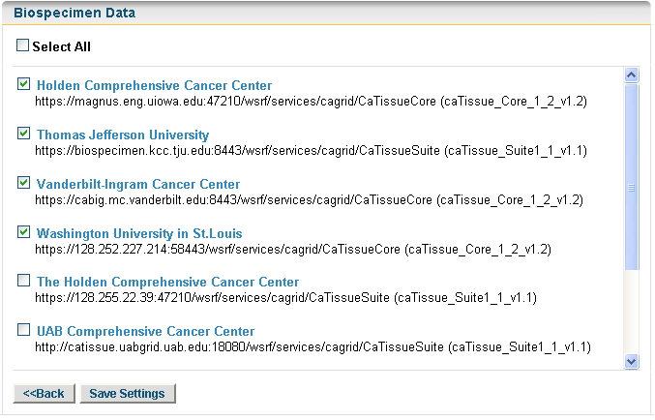
Previously selected institutes
Figure 2.5. Hosting institutions for biospecimen data
Hosting Institution details shows the application model name and version to identify the service available at a particular institute.

- Select the check boxes for the hosting institutions from where you wish to fetch the data and click Save Settings to save the hosting institutions
To select or deselect all the institutes click Select All check box.

- If you do not want to change the settings then click Back to return back to the Home page
WARNING! | If you have not signed in then, hosting institutions selections are lost once you close the application. When you access the application again, the settings might have changed. If you sign into the application, then the hosting institution settings are persisted. When you signs in again, you will see your previous selections.

Keyword Search
This chapter describes how to fetch data from caGrid data services using a keyword-based search. It contains following topics:
- Introduction to Keyword Search
- Steps to Perform Keyword Search
- View Results
- Export Results

Introduction to Keyword Search
Keyword search is the simplest type of search to get data. If you are new to caGrid-caB2B and looking for what kind of data is present on caGrid. Then you should be using keyword search. It allows you to get information like
- Microarray experiment details
- Biospecimen details along with the participant information
- Study details for an image
- Nanoparticle sample details
You just need to enter disease name, assay type, tissue site, specimen type, etc to get this information.
Administrator of caB2B identifies and creates most widely used queries for each type of data. When you perform keyword search, application executes these predefined queries using the keyword. To get the data, application queries selected institutions. Refer to for more details.
For example, if you want to search for biospecimen data available for Melanoma, then enter a keyword Melanoma. This search will return biospecimen collected along with the participant information.

Steps to Perform Keyword Search
- Select the type of data from the dropdown What type of data do you wish to search for?, like Biospecimen Data. (refer to Home Page)
- Select the institutions you wish to query using Databases to Search (refer to )
- Type the search string in the text box next to Keyword Search, for example Melanoma.
- Click Search.

Figure 3.6. Keyword Search
Application navigates to the result view.

If you specify a phrase while searching, results would contain the exact phrase. For example, if you query for Spindle Cell Melanoma, then the results would match the entire phrase and not a word. It will not contain results for Melanoma or Cell.

View Results
As explained above, for keyword search, application executes a set of predefined queries on the institutions you had selected. On the result page, you will see following information:

Multiple Queries
As explain above, keyword search uses administrator-defined queries to retrieved data. Results for dropdown shows the list of all such queries. On changing the query, you will see data fetched for that query.

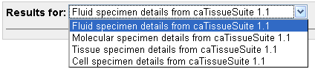
Figure 3.7. Dropdown showing different queries with the result count

Result Table
Application displays results of your keyword query in a tabular format. For each query, you would see a single table with a maximum of hundred records on user interface. In addition to the data, application also displays short name of the hosting institution from which it is retrieved. Until the point application is getting data for your query, you will see a screen below
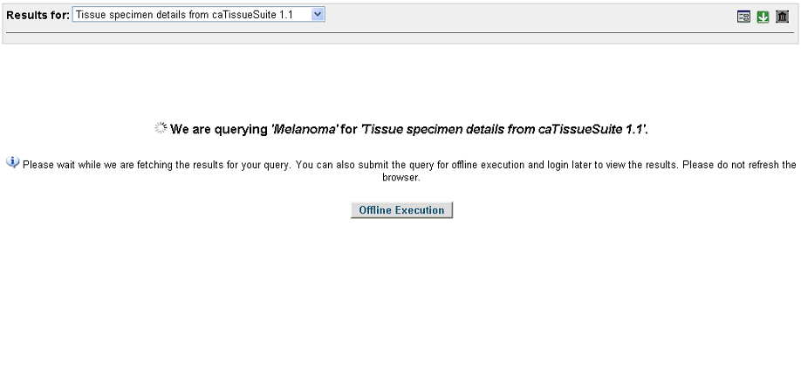
Figure 3.8. Wait screen before results appear
As soon as the application retrieves some results, it will start showing the result table. The image below shows the result table.
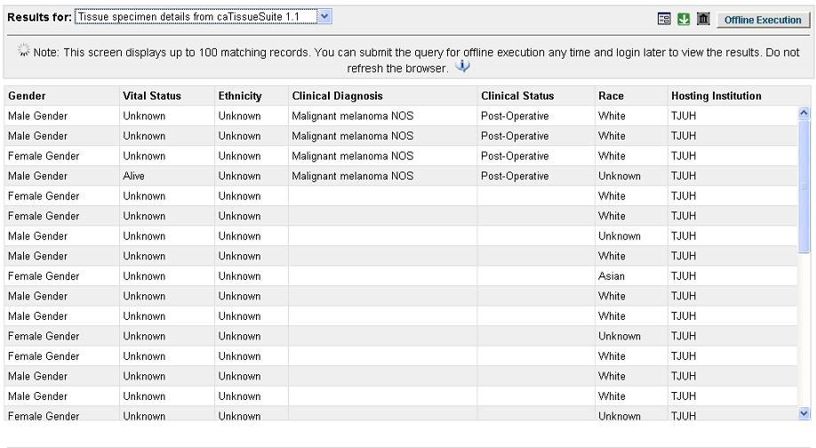
Figure 3.9. Result table with a few results
Application updates the result table as and when more data is returned. Figure below shows the result table when the query is complete.
Offline Execution option is available while the query execution is in progress.

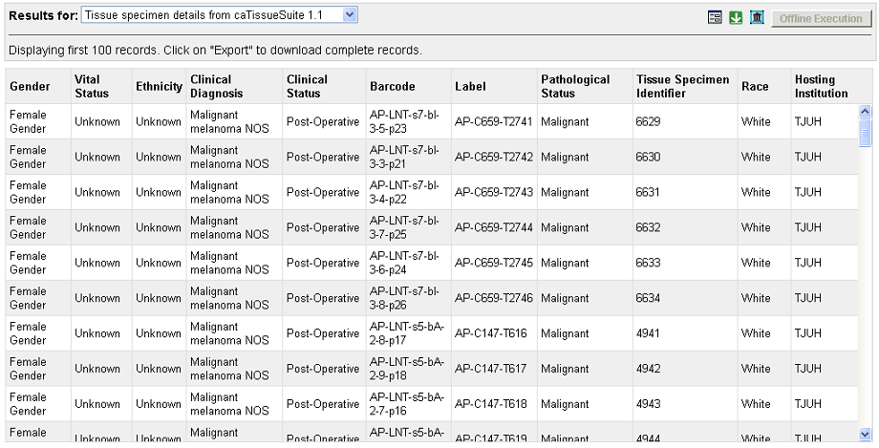
Figure 3.10. Results for Keyword Search

A signed in user can submit the query for offline execution and later sign in to view the results of the query. For more details of offline execution, refer to Offline Query Execution.

Options on Result Page
Figure 3.10. Results for Keyword Search , shows the various options available on the result page at the top right hand corner. These options are:
- Query Parameters: You can mouse over to see the limits defined for the query on the result page.
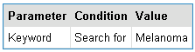
Figure 3.11. Query Parameter
- Failed Hosting Institutions: You can click to see the institutions that failed to return results. If no institutes failed, then you would see . To know more, refer to Failed Hosting Institutions.
- Export: You can click to download the results when the query execution is complete. Refer to section Export Results below for more information on export.
- Offline Execution: This option is only available to the signed in users. You can submit the query for offline execution and navigate away. When you sign in later, you can go to query dashboard to export the results. Refer to Offline Query Execution for more information on offline execution.

Export Results
Once the query is complete, you can export the results of your query in csv (comma-separated file) format. When you click, application will prompt you to download a zip file. For a keyword query, there are multiple files present in the downloaded zip file. The result for each administrator-defined query is stored in a separate file. The exported csv file contains the following information:
- Query Title: Title of the query, like Tissue specimen details
- Query Description: Description of the query, like Finds all tissue specimens based on participant information and clinic-pathological information from a particular tissue site
- Execution Date: Time at which query started its execution
- Executed By: Your caGrid user name
- Conditions: This section describes the conditions used to execute the query. It includes conditions you have added along with conditions specified by administrator
- Results: This section displays the result of the query. You can view all the records in the exported results. In addition to the data, the following information is added to the exported results:
  - Name of the application from which the data is fetched
  - Full name of the hosting institution, point of contact and email address
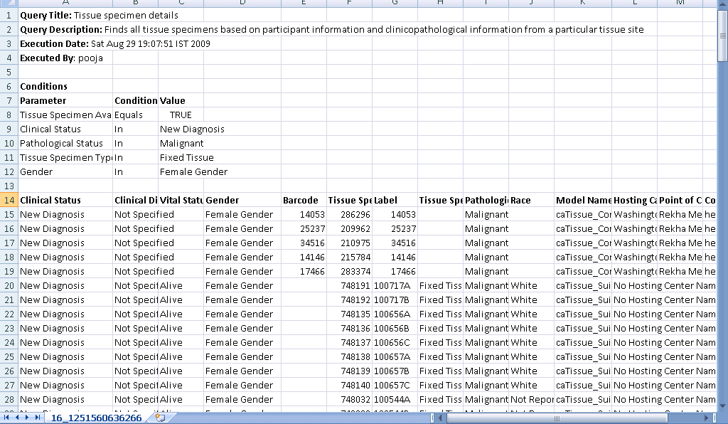
Figure 3.12. Exported results for Tissue specimen details

Saved Searches
This chapter describes how to fetch data from institutions using a saved search. It contains following topics:
- Introduction to Saved Search
- Steps to Define Limits
- View search Results
- Export Results

Introduction to Saved Search
A saved search allows you to set conditions on limits and execute the query. Unlike keyword search, saved search is more systematic as you define conditions on certain set of attributes.
As explained previously, for keyword search, application executes administrator-defined queries to retrieved data. If you want a very specific search, you can choose one of the saved searches. It shows you specific attributes-operators-values. You can use these to define limits to build a complex query. As it is a directed search, it is helpful and very effective. Also due to lesser number of queries, saved search is faster as compared to the keyword search.
Each saved search consists of a set of attributes on which you can define a limit. For example, if you want to find the malignant Melanoma tissue specimens then, you would use search Tissue specimen details and specify Clinical Diagnosis attribute equal to Melanoma and Pathological Status attribute in Malignant.
Administrator of the Web Application creates the saved searches. If you want certain saved search in the Web Application, contact your caB2B administrator.

Steps to Define Limits
Define limits page appears when you select a saved search from the home page. The define limit page displays the limits on which you can define a condition. You can define a condition by choosing an operator and value. The value can be a word or a phrase. Some attributes contain a fixed set of values; you can choose one or more values from this set to define a condition.
Follow the steps given below to define limit and execute a saved search:
- Select the type of data from the dropdown What type of data do you wish to search for?, like Biospecimen Data. (Refer to Home Page).
- Click a query name from the Saved Searches panel, example, Tissue specimen details.
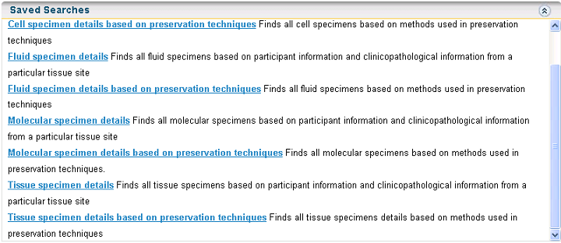
Figure 4.13. Saved searches for Biospecimen data
Define Limits page appears.
- Add a limit to the available Variables, example Clinical Diagnosis Contains Melanoma and Pathological Status In Malignant.
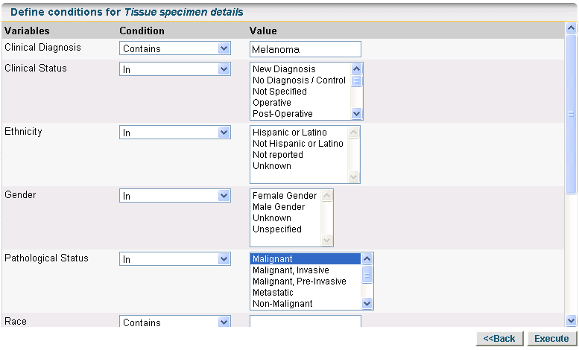
Figure 4.14. Define Limit
To know more about defining limits and how to specify the limits and values, refer to Appendix B: Define Limit: Operators and Values.

- Click Execute.
Application will navigate to the result view

View search Results
The saved search results page is similar to the keyword search page. As you are executing a single query, the Results For displays the title of the query instead of the dropdown. You can see the number of results fetched next to the query title. On the result page, you will see following information:

Result Table
Application displays results of your saved search in a tabular format. For the search, you would see a single table with a maximum of hundred records on the user interface. In addition to the data, application also displays short name of the hosting institution from which it is retrieved. Until the point application is getting data for your query, you will see a screen as shown below

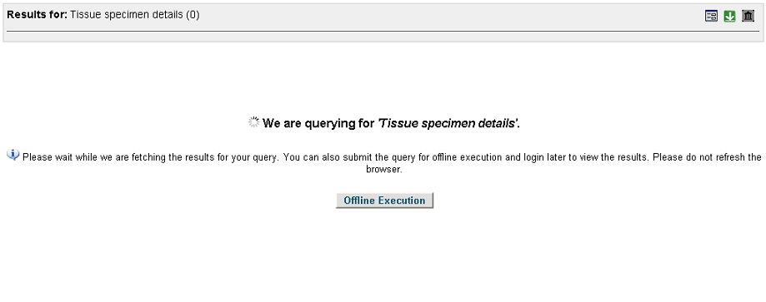
Figure 4.15.Wait screen before results appear
As soon as the application retrieves some results, it will start showing the result table. The image below shows the result table.

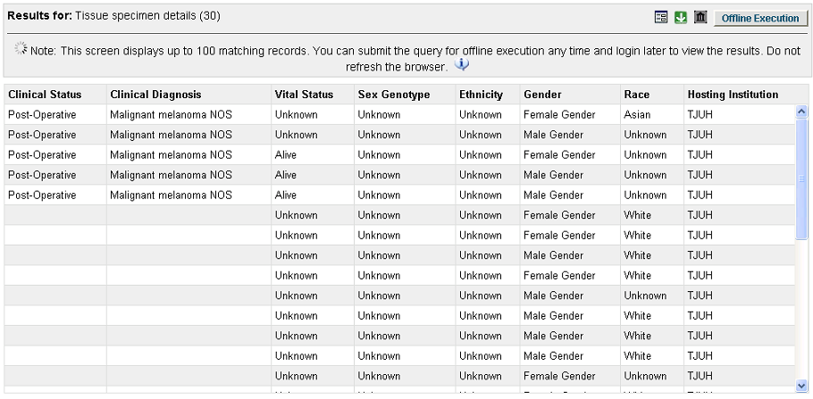
Figure 4.16. Result table with a few results
Application updates the result table as and when more data is returned. Figure below shows the result table when the query is complete.

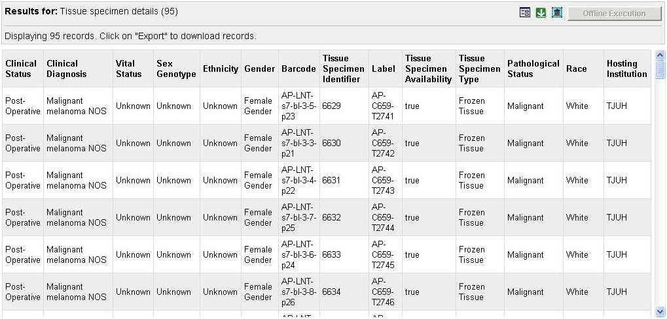
Figure 4.17. Result for Saved Search

A signed in user can submit the query for offline execution and later sign in to view the results of the query. For more details of offline execution, refer to Chapter Offline Query Execution.

Options on Result Page
Figure 4.17. Result for Saved Search, shows the various options available on the result page at the top right hand corner. These options are:
- Query Parameters: You can click to see the limits defined for the query on the result page.
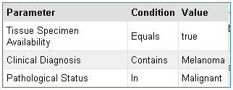
Figure 4.18. Query Parameters
- Failed Hosting Institutions: You can click to see the institutions that failed to return results. If no institutes failed, then you would see.
- Export: You can click to export and download the results when the query execution is complete. Refer to section Export Results in keyword search for more information on export.
- Offline Execution: This option is only available to the signed in users. You can submit the query for offline execution and navigate away. When you sign in later, you can go to query dashboard to export the results. Refer to Offline Query Execution for more information on offline execution.

Export Results
The Export option for a saved search is same as that of a keyword search. The only difference being that the downloaded zip file contains a single file for a particular query. For more details of various options available, refer to Export Results in keyword search section.

Offline Query Execution

This chapter describes how you can submit a query to execute in background and view the result later. In contains the following topics:
- Introduction to Offline Query Execution
- Steps to Execute Offline Queries
- Query Dashboard

Introduction to Offline Query Execution
Offline query execution means that you can submit a query to run in background and view the results later. You can navigate away from the application when you submit the query for offline execution. You can submit queries for offline execution only if you have signed in with your caGrid credentials.
Offline query execution is particularly useful in cases where your query fetches large amount of data. It is not possible for you to wait until the application fetches all the results. In such scenarios, you can submit queries for offline execution.
Once you submit a query for offline execution, it is available on the query dashboard for future reference. You can sign in any time and check the status of your queries. When the query execution completes you can download the results and save it.
Query dashboard displays all the queries that you had submitted for offline execution. In addition, it also shows information such as query status, number of results fetched, hosting institution status etc.

Steps to Execute Offline Queries

You can submit keyword as well as saved search for offline execution. To submit a query for offline execution, follow the steps below:
- Sign in to the application using your caGrid credentials.
- Select a data type from the What type of data do you wish to search for?
- To execute a query,
  - For keyword search,
    - Type in a keyword
    - Click Search (refer to Figure 3.6. Keyword Search).
  - For saved search, from the Saved Search panel select a query to execute (refer to Figure 4.13. Saved searches for Biospecimen data).
    - Specify the limits on the Define Limits page (refer to Figure 4.14. Define Limit). For more details, refer to Steps to Define Limits.
    - Click Execute.
- On the results page click Offline Execution (refer to Figure 3.9 or Figure 4.16).
Once you submit a query for offline execution, the application navigates to the query dashboard.

Query Dashboard
Query dashboard shows all the queries that you had submitted for offline execution. It is available only to the signed in users. The following figure shows your dashboard:
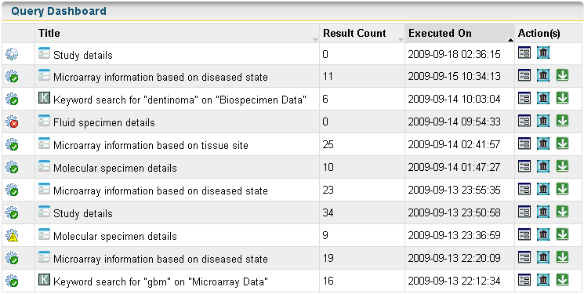
Figure 5.19. Query Dashboard
The dashboard provides the following information:
- Query Status: Status of the query. Query status can be either:
  - In progress : Query execution is in progress.
  - Complete : Query execution is complete.
  - Failed : Query execution failed.
  - Some data could not be fetched : A part of the query failed.
  - Suspended : Query could not complete as the application stopped abruptly.

If the caB2B application shuts down abruptly, the query shows the suspended status. If a query is suspended then, the export option is not available even though the result count shows that the results were fetched.

- Query Type: Type of the query. There are two types of query:
  - Keyword query:
  - Saved search:
- Query Title: Title of the query, like Tissue specimen details
- Result Count: Count of results fetched by the query
- Execution On: Time at which query started its execution
- Query Parameters : The condition set while executing the query. Figure below shows the query parameters:
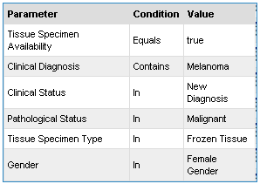
Figure 5.20. Query Parameters
- Hosting Institution Information : The hosting institutions you selected for the query. The figure below shows the hosting institution information:
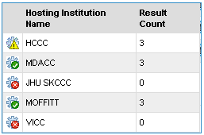
Figure 5.21. Hosting Institute Information
The tool tip displays the following information:
- Institution Status: The status reflects whether the institution could be queried or not. The status can be:
  - Complete:
  - Failed:
  - Some data could not be fetched:
- Hosting Institution Name: Short name for the hosting institution
- Result Count: Number of results retrieved from each institution.
- Export Results : It allows you to download the results once the query execution is complete.
You can sort the queries on the dashboard based on any of the columns available. The dashboard displays all the queries that you had executed in background in the last 20 days. You should therefore, download all the results and store them locally.

Error Messages/Indicators and Problem Resolutions
This chapter provides help in dealing with certain common error messages and their solution. It covers the following erroneous situations:
- Accessing secure data
- Invalid login credentials
- Failed Hosting Institutions

Accessing secure data
To access secure data you need to sign in to the application using your caGrid credentials. For example, Biospecimen data is secure so if you try to select Biospecimen data, application gives a message asking you to sign in.

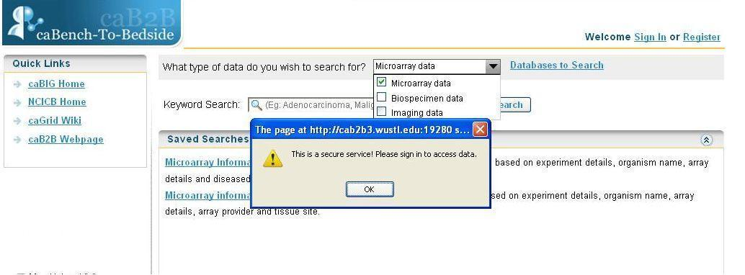
Figure 6.22. Error message on accessing secure data

Invalid login credentials

Web Application gives error if invalid login credentials are used.

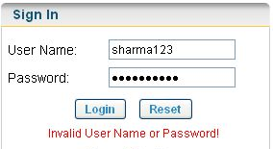
Figure 6.23. Invalid grid credentials error message

Failed Hosting Institutions

caB2B web application allows to select the hosting institution from where you wish to search data (refer to ). If any hosting institution fails to return results then, you would see on the result page. You can click it to view the failed hosting institution.
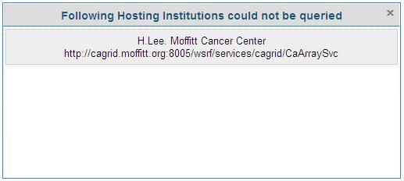
Figure 6.24. Failed Hosting Institution
You can go to the Databases to Search page and remove the failed hosting institution.

Example for searching data
This appendix provides example of searching data:
- Keyword Search
- Saved Searches

Keyword Search
To find biospecimen data for Melanoma you can use keyword search. Follow the steps given below:
- Select Biospecimen data from What type of data do you wish to search for? dropdown
Figure A.25. Select data type
- Click Databases to search and select Thomas Jefferson University’s caTissue Suite instance for query (refer to Figure 2.5).
Figure A.26. Databases to Search
- In the Keyword Search text box, enter Melanoma.
- Click Search (refer to Figure A.4).
Figure A.27. Keyword Search
Application navigates to the results page.
Figure A.28. Keyword Search Result
- Change the query in the Results for dropdown to view the results for another query
Figure A.29. Multiple Keyword Queries
- Click to export the results as a csv file.

Saved Searches

To find malignant Melanoma tissue specimens you can use the Saved Searches. Follow the steps given below to execute the search:

- Select Biospecimen data from What type of data do you wish to search for? dropdown(refer to Error: Reference source not found)
- Click on Databases to Search and select Thomas Jefferson University’s caTissue Suite instance for query.(refer to Error: Reference source not found)
- Click on Tissue specimen details from the saved searches panel.

Figure A.6. Select Saved Search
Application navigates to the Define Limits page.

- Define limit on Clinical Diagnosis contains Melanoma and Pathological Status In Malignant.
Figure A.7. Define Limits
- Click Execute.

Application navigates to the results page.

Figure A.8. Saved Search Results
- Click to export the results as a csv file

Define Limit: Operators and Values
This appendix explains the various operators available for query. It also explains how to specify values while defining limits on a query.
The following table explains the different operators and provides examples as to how values are to be specified.

Operator | Data types for which applicable | Sample condition | Expected Results
Equals | Numeric  Date  String | Tissue Site equals “Cerebellum” | Returns all specimens with tissue site only Cerebellum and not cerebellum
Not equals | Numeric  Date  String | Tissue Site not equals “Cerebellum” | Returns all specimens with tissue site other than Cerebellum
Is null | Numeric  String  Date | Experiment description is null | Returns all experiments which do not have any description
Is not null | Numeric  Date | Experiment title is not null | Returns all Experiments whose title is specified
In | Numeric  String  Enumerated | Pathological Status in Malignant | Returns all specimens whose pathological status is malignant
Not in | Numeric  String  Enumerated | Pathological Status not in Malignant | Returns all specimens whose pathological status is not malignant
Starts with | String | Tissue Site starts with pr | Returns all specimens whose tissue site starts with pr like prostate  Does not return the specimen with tissue site ovary
Ends with | String | Clinical Diagnosis ends with noma | Returns all specimens whose clinical diagnosis ends with noma like adenoma, carcinoma and melanoma. Does not return specimen with diagnosis gangrene
Contains | String | Clinical Diagnosis contains noma | Returns all specimens whose clinical diagnosis is adenoma, carcinoma, and melanoma. Does not return specimen with clinical diagnosis meningioma

- For attributes with enumerated values and Boolean attributes, clear a value by clicking on the value with the CTRL key pressed.
- If you use the In operator for a non-enumerated attribute, you can specify multiple values as follows:
- Separate multiple values using a comma. For example, to specify the constraint Clinical Diagnosis IN adenoma, carcinoma, melanoma, you should type the value as adenoma, carcinoma, melanoma.
- For attributes with enumerated values, you can select multiple values by selecting the value with the CTRL key pressed.

Index

C
caB2B, 3
caB2B admin module, 4
caBIG, 1, 3, 5
caBIG®, 3
caGrid, 3, 12, 17
Category
definition, 7
D
dashboard, 6, 15, 21, 22, 23, 25
Databases to search, 10
Define Limits, 17, 22, 30
E
export, 1, 3, 30, 31
Export, 3, 9, 12, 15, 17, 21, 25
F
Failed Hosting Institutions, 27
K
Keyword Search, 6, 12, 14, 15, 22, 28, 29
L
Limits
definition, 8
login, 5, 26
N
NCI, 3
O
Offline Execution, 14, 15, 21, 23
Q
Query
definition, 8
Query Parameters, 15, 20, 24
Query Wizard, 12, 13
R
register, 5
S
save settings, 11
Saved Search, 6, 17, 20, 22
Saved searches, 17
service instances, 10
T
translational research, 1
V
View search Results, 18

